URWERK – Birth of the UR-100V Time and Culture line

Geneva, 23 March 2022.
Writing time, transcribing the intangible, giving substance to the passing hours. For thousands of years, this has been one of the "impossible missions" assigned to the masters of time. From the pyramids of the City of Ur to the gnomons from China and lunar calendars engraved in rock, they have incessantly deployed their genius, inventiveness and even pugnacity in testifying to the passing of days and hours. It is to this quasi-heroic work that URWERK pays tribute today with its new 100V Time and Culture line. Introducing the first episode based on an original idea of SJX …
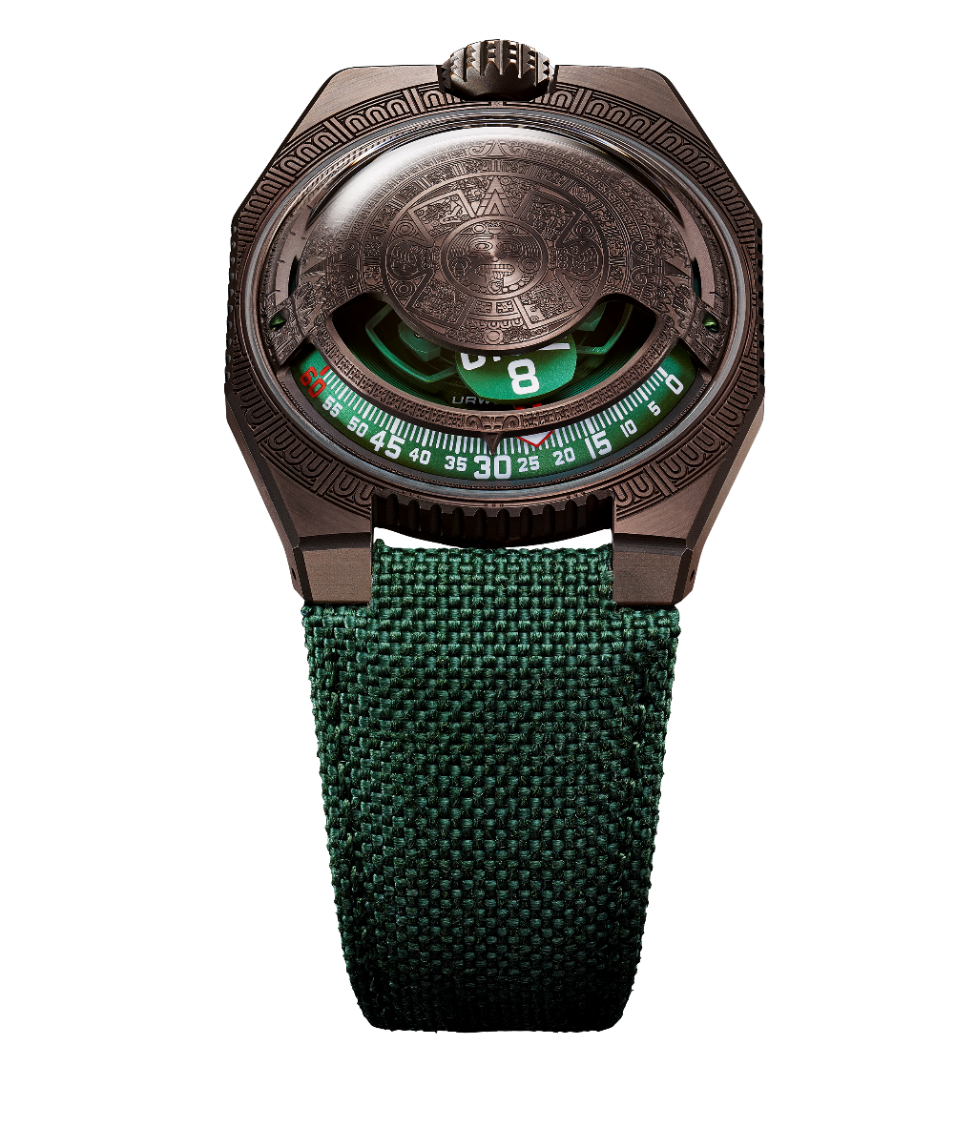
The new line of the 100V, dedicated to perceptions of time through the ages and cultures, has been named Time and Culture. "This line is about History, Cultures, our place beneath the stars, the research and observations that have been conducted around the world using the same sky above our heads as a source of knowledge. I am always fascinated to see that these unique observations, made thousands of kilometres away, have given birth to a universal language, that of time”, explains URWERK co-founder Martin Frei. We are therefore literally being treated to a journey through space-time. And to materialise such a journey, the UR-100V, combining indications expressed in minutes and kilometres, proved to be the ideal vehicle.

The first stop in the 100V Time and Culture line takes us to the lands of Central America, around the year 1479. The pediment of this timepiece features the motifs of the "Sun Stone", one of the most emblematic works of Aztec art, now preserved in the National Anthropology Museum in Mexico City. This monolith is a sculpted disc approximately 3.6 metres in diameter. Imposing. Massive. This masterful work refers to the Aztec calendar, with the third circle representing the 20 days of the month, the fourth the 260 days of the year.
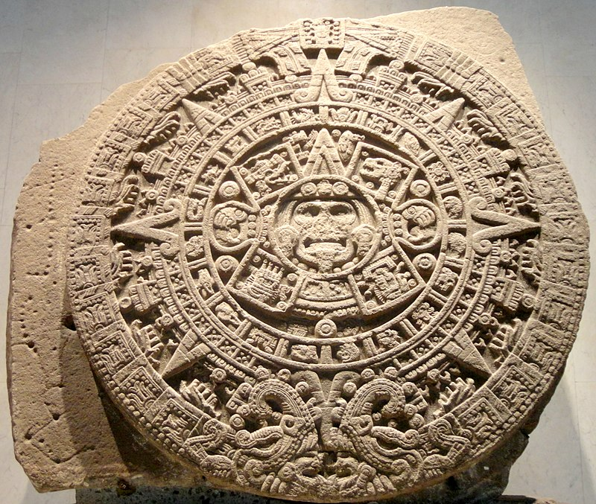
© Juan Carlos Fonseca Mata

This pattern is therefore repeated on the copper-coloured dome of the UR-100V Time and Culture I. The result is exquisitely delicate. The milling cutter used for the engraving has a 0.05 mm-thin point. The work must therefore be admired with a magnifying glass to appreciate its precision. The ridge lines of the motif are satin-brushed, while the hollows are micro-sandblasted to obtain a velvety finish, in order to highlight the volumes and honour this priceless heritage.
Beauty, history and mysticism are intertwined. The universal significance of this new URWERK is further reinforced by learning that the source of inspiration for this piece comes from Singapore. Su Jia Xian, better known by his acronym SJX, put forward an idea to Felix Baumgartner and Martin Frei three years ago: adding an extra dimension to the UR-100 by closing the top just like on the first edition of the UR-103, creating something special that transcends space and time, literally and figuratively. The UR-100V Time and Culture I has thus gained a foothold in Central America. Felix Baumgartner, co-founder of URWERK, adds, "This timepiece has several interpretative keys, starting with its obvious universal significance: it is inspired by the Aztec culture; it was made in Switzerland, based on an idea from Singapore; it will end up in the windows of a retailer whose nationality is not yet known, and it will appeal to an equally unknown watch lover. Yet it also conceals certain secrets. We have sprinkled our work with hidden references. The discerning eye will be able to make out a signature, an acronym, a Mayan numbering to be deciphered. It's a real treasure hunt.”

On this UR-100V from the Time and Culture line, a new piece of information is added to the hours and minutes display. Once the 60th minute has passed, the minutes hand disappears and reappears as a kilometre counter. It illustrates the 524.89 kilometres covered every 20 minutes by any person located in Mexico. This is the average speed of the Earth's rotation calculated at Mexico City. On the opposite side of the spectrum, the Earth's revolution around the sun is displayed, i.e. 35,742 kilometres per 20 minutes. On the face of the UR-100V, hours and kilometres thus share the same status, the same scale of value. These units are lit up in incandescent blue when reading the hours.

UR-100V Time and Culture I
(on an original idea by SJX)

Movement | Calibre UR12.02 with automatic winding system regulated by the Winfänger system with its streamlined propeller.
Jewels | 40
Frequency | 28,800 vph – 4 Hz  S
Power reserve | 48 hours
Materials | Aluminium satellite hours mounted on beryllium bronze Geneva crosses; aluminium carousel; ARCAP dome
Finishes | Circular graining, sandblasting, microblasting, circular satin finishing  Chamfered screw heads  Hour- and minute-markers painted with Super-LumiNova®
Indications | Satellite hour display; minutes; distance travelled to Mexico City in 20 minutes, revolution of the Earth around the Sun in 20 minutes
Case
Material | Steel bezel, titanium back
Dimensions | Width: 41 mm ; length: 49.7 mm, thickness: 14 mm
Glass | Sapphire crystal
Water resistance | Pressure-tested to 3ATM (30 m)
Strap | Baltimora; pin buckle
Price | CHF 68,000.00 (Swiss francs / excluding tax)  20-piece limited edition

Contact: Ms Yacine Sar
press@urwerk.com
www.urwerk.com
+41 22 900 20 27

