The UR-100V Magic T
or when URWERK offers revisits the principles of minimalism

Geneva – 26 April 2023
After the black of carbon and the muted grey of raw titanium, URWERK continues to explore these ‘cold’ colours that come to life under the light and enlighten the informed eye. More than just work on colour, the new UR-100V Magic T is about research into nuances, reflections and chromatic subtleties. It features a luminous and intense metallic grey, now delicately nestled on the wrist. From case to bracelet, this UR-100V Magic T is all about titanium and pure magic.

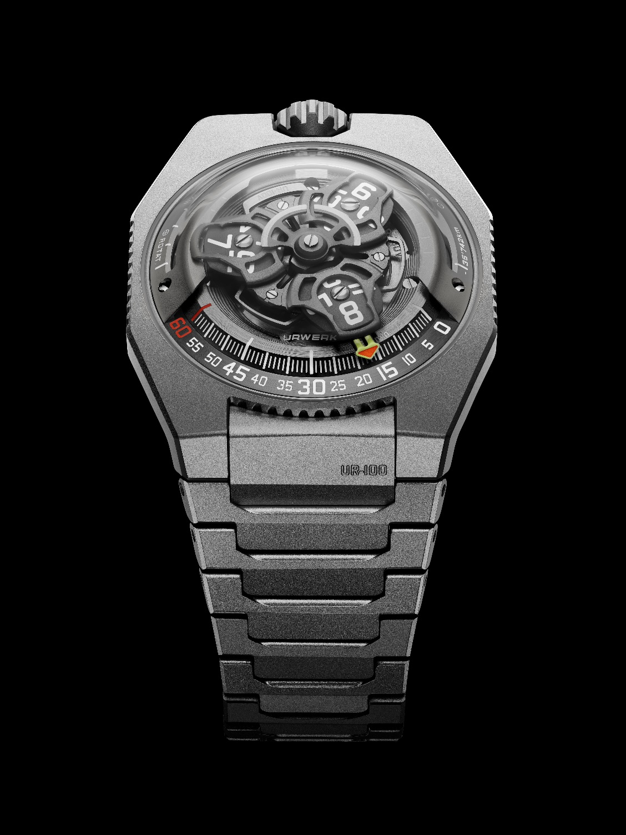

Like a blank page, the UR-100V lends itself to all its creators’ desires and fanciful touches. "The look of this 100 collection offers scope for endless interpretations”, explains URWERK's artistic director and co-founder Martin Frei. “We have created a watch that assumes the role of our 'classic'. A versatile timepiece that changes mood and appearance over time. And even though I am one of its creators, I perpetually discover and rediscover it in its different variations, always with the same impatience and the same pleasure", he concludes.

"This UR-100V Magic T fully deserves its nickname evoking the magic of titanium. This material lends itself beautifully to the finest finishes. We have loved and admired raw titanium, and now we have it gleaming in full brilliance, thanks to light, refined shot-blasting. All the beauty of the metal is there. We also worked on the legibility of our timepiece, adding complexity to the dial that is now broken down into several elements to give it more structure. Try to distinguish between the many different levels of this 3D creation and you will discover that everything has been thought through right the way down to the smallest details, pushing the limits of perceptibility”, says Felix Baumgartner, master watchmaker and co-founder of URWERK.

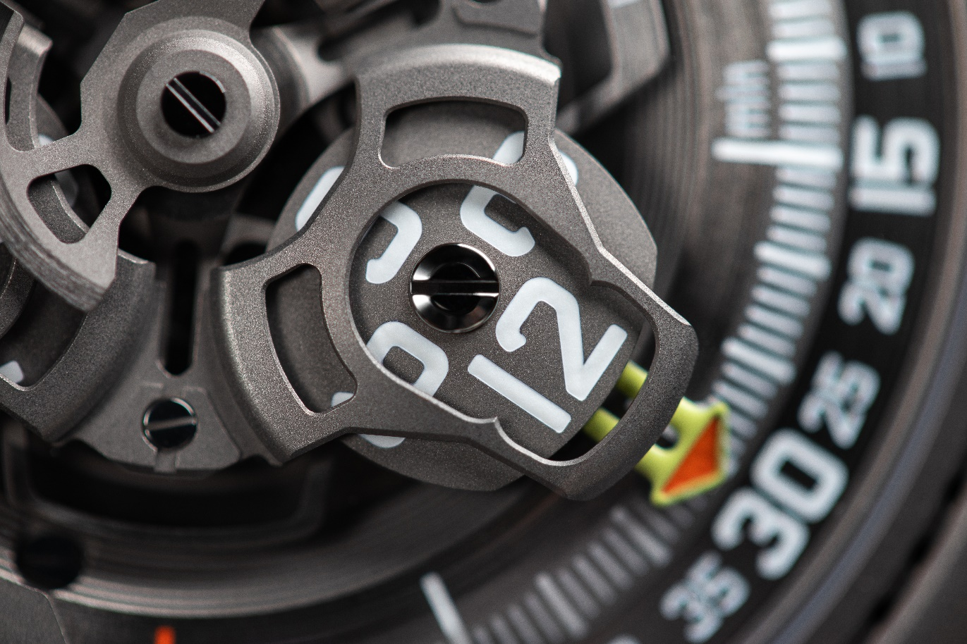

Right from the outset, the 100 collection was conceived with simplicity and minimalism in mind. ‘Simple’ is an easily uttered word that nonetheless cannot totally reflect the full extent of Martin Frei's aesthetic linguistics and Felix Baumgartner's horological technicality. The former plays with shapes, creating a design vocabulary that is a living language. The latter constantly reinvents new ways of bringing to life URWERK wandering hours – the principle of hands-free hours and minutes display based on satellites moving along a graduated arc of a circle. A first carries the hours and the other the minutes. And when one hours satellite has completed its 60 minutes, the next one bearing the next hour appears in front of the number zero minutes index.

No one would have imagined that this principle, extrapolated from a 17th century clock, could be explored, transformed and transmuted with such creativity in space, volume and time. URWERK's capacity for reinvention without ever deviating from its fundamental principles is doubtless the core reason behind its longevity. Demonstrating a strong sense of nuance, the UR-100V Magic T can logically be compared to a ‘colour exploration vehicle’. In the metaphorical sense, it is just as much so as its predecessors; while aesthetically speaking, many of its details relate to celestial bodies.

Even more explicitly than all other URWERK creations, the UR-100V is entirely bound up with the realm of space. Not just because its design can be described as that of an UFO. Not merely because its impossible-to-categorise design evokes a whole different dimension beyond the boundaries of current watchmaking. It bears two long recesses on the sides of its satellite carrier. The first is a counter for kilometres – those travelled by the Earth along its own axis in 20 minutes, namely 555. The other also counts kilometres – this time those travelled by the Earth around the Sun during the same period of time, namely 35,740. The UR-100V thus bear witness to the Earth’s trajectory through the interstellar void, where our blue planet is accompanied by a Magic T-coloured heavenly body.

UR-100V Magic T – Limited edition

Movement
Calibre | Selfwinding UR 12.02 movement governed by a Windfänger airscrew
Jewels | 40
Frequency | 28,800 v/h - 4Hz
Power reserve | 48 hours
Materials | Satellite hours on beryllium-bronze Geneva crosses; aluminium carousel; carousel and triple baseplates in ARCAP alloy
Finishes | Circular graining, sanding, shot-blasting, circular satin finishing  Chamfered screw heads  Hours and minutes painted in Super-LumiNova®
Indications | Satellite hours; minutes; rotational distance at the Equator in 20 minutes; orbital distance in 20 minutes
Case
Material | Sanded shot-blasted titanium.
Dimensions | Width: 41.0 mm, length: 49.7 mm, thickness: 14.0 mm
Glass | Sapphire crystal
Water resistance | Pressure-tested at 3ATM (30m)
Bracelet | Titanium, with 32 sanded shot-blasted links
 | Price : CHF 58,000 (Swiss francs / excluding tax)

____________________

Contact: Ms Yacine Sar
press@urwerk.com
www.urwerk.com
+41 22 900 20 27

